**Smart public restrooms**, often referred to as "intelligent" or "connected" public restrooms, represent a modern and innovative approach to providing essential sanitation facilities in public spaces. These restrooms leverage technology and automation to enhance user experience, improve hygiene, and streamline maintenance. Here is an overall introduction to smart public restrooms:

1. **Advanced Technology**: Smart public restrooms are equipped with various cutting-edge technologies such as sensors, IoT (Internet of Things) devices, and digital interfaces. These technologies work together to enhance the restroom's functionality and user-friendliness.

2. **Enhanced User Experience**: These restrooms prioritize user comfort and convenience. For instance, automatic sensor-based faucets, soap dispensers, and flush systems minimize touchpoints, promoting hygiene and reducing the spread of germs. Smart restrooms may also feature touchless entry systems and occupancy indicators to help users quickly identify an available restroom.

3. **Energy Efficiency**: Smart restrooms often incorporate energy-efficient lighting and heating systems. Sensors can detect occupancy and adjust lighting and temperature accordingly, saving energy when the restroom is not in use.

4. **Maintenance and Cleaning**: Monitoring sensors help restroom operators keep track of traffic and usage patterns, enabling proactive maintenance and cleaning schedules. This can help ensure that the restrooms are consistently clean and well-maintained.

5. **Safety and Security**: Some smart restrooms are equipped with safety features, such as emergency call buttons or alarms, to ensure user security. Additionally, digital surveillance systems may deter vandalism and provide evidence in case of misconduct.

6. **Accessibility**: Smart public restrooms are designed to be accessible to people with disabilities. This includes features like ADA-compliant stalls, braille signage, and auditory cues for guidance.

7. **Eco-Friendly Features**: Many smart public restrooms incorporate sustainable and eco-friendly elements, such as low-flow toilets and water-saving fixtures to reduce water consumption. Some may also feature solar panels to generate renewable energy.

8. **Public Health**: Smart restrooms contribute to public health by promoting hygiene and sanitation. Touchless fixtures, automatic flush systems, and regular cleaning routines help prevent the spread of diseases.

9. **Digital Interfaces**: Smart restrooms may have digital interfaces that provide information to users, such as occupancy status, cleanliness ratings, and directions to nearby amenities. Mobile apps may also be integrated to help users locate and access these restrooms.

10. **Data Collection**: These restrooms collect data on usage patterns, foot traffic, and resource consumption. This data can be valuable for city planners, businesses, and facility managers to optimize restroom locations and improve overall service.

11. **Customization**: Smart public restrooms can be customized to meet the specific needs and aesthetic preferences of the location or community they serve. They may blend seamlessly into urban environments or stand out as architectural landmarks.

In summary, smart public restrooms are a fusion of technology and sanitation, aimed at providing enhanced user experiences, improving hygiene, and promoting sustainability. These innovative facilities are becoming an integral part of modern urban planning, ensuring that public restrooms are safe, clean, and efficient for all users.

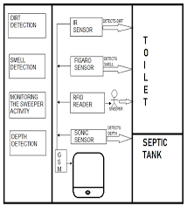

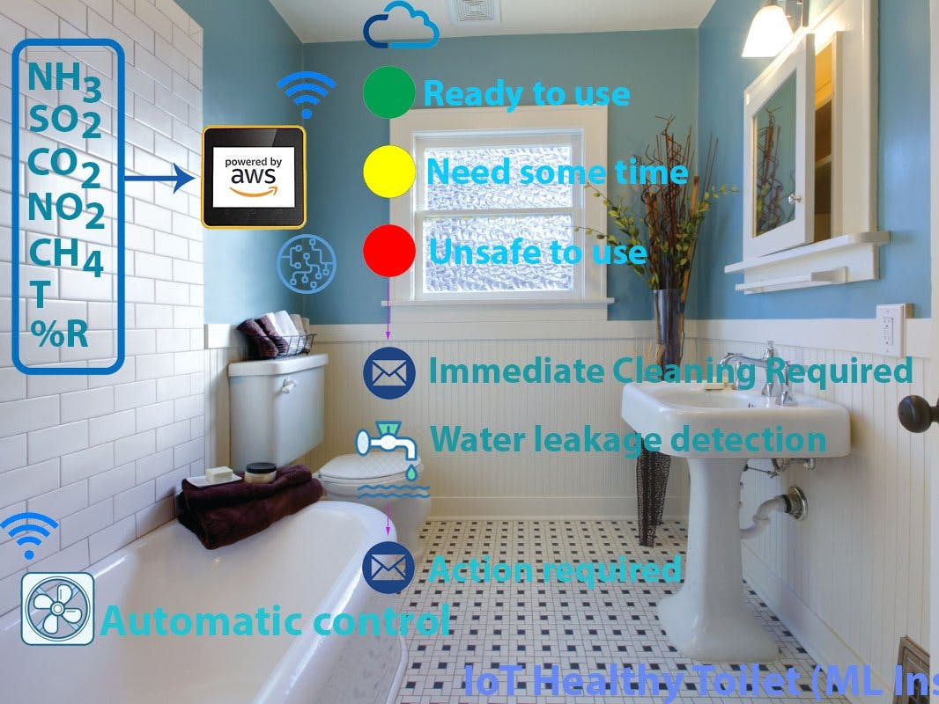

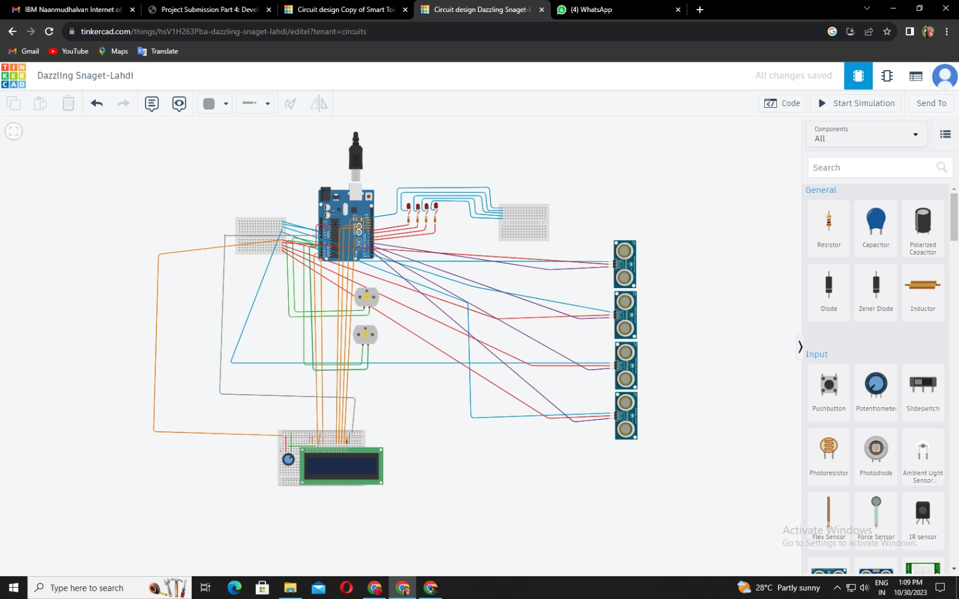

Link: https://www.tinkercad.com/things/3rjsFOwIsh3-copy-of-smart-toilet/editel?tenant=circuits

#include <LiquidCrystal.h>

LiquidCrystal lcd(18, 19, 10, 11, 12, 13);

int ledA = 6;

int ledB = 7;

int ledC = 8;

int ledD = 9;

int ULT1 = 2;

int ULT2 = 3;

int ULT3 = 4;

int ULT4 = 5;

int fanA1 = 14;

int fanA2 = 15;

int fanB1 = 16;

int fanB2 = 17;

int cm1 = 0;

int cm2 = 0;

int cm3 = 0;

int cm4 = 0;

int A,B,C,D,E;

long bacaULT1(int pin)

{

pinMode(pin, OUTPUT); // Clear the trigger

digitalWrite(pin, LOW);

delayMicroseconds(2);

// Sets the pin on HIGH state for 10 micro seconds

digitalWrite(pin, HIGH);

delayMicroseconds(10);

digitalWrite(pin, LOW);

pinMode(pin, INPUT);

// Reads the pin, and returns the sound wave travel time in microseconds

return pulseIn(pin, HIGH);

}

long bacaULT2(int pin)

{

pinMode(pin, OUTPUT); // Clear the trigger

digitalWrite(pin, LOW);

delayMicroseconds(2);

digitalWrite(pin, HIGH);// Sets the pin on HIGH state for 10 microseconds

delayMicroseconds(10);

digitalWrite(pin, LOW);

pinMode(pin, INPUT);

// Reads the pin, and returns the sound wave travel time in microseconds

return pulseIn(pin, HIGH);

}

long bacaULT3(int pin)

{

pinMode(pin, OUTPUT); // Clear the trigger

digitalWrite(pin, LOW);

delayMicroseconds(2);

digitalWrite(pin, HIGH);// Sets the pin on HIGH state for 10 micro seconds

delayMicroseconds(10);

digitalWrite(pin, LOW);

pinMode(pin, INPUT);

// Reads the pin, and returns the sound wave travel time in microseconds

return pulseIn(pin, HIGH);

}

long bacaULT4(int pin)

{

pinMode(pin, OUTPUT); // Clear the trigger

digitalWrite(pin, LOW);

delayMicroseconds(2);

digitalWrite(pin, HIGH);// Sets the pin on HIGH state for 10 micro seconds

delayMicroseconds(10);

digitalWrite(pin, LOW);

pinMode(pin, INPUT);

// Reads the pin, and returns the sound wave travel time in microseconds

return pulseIn(pin, HIGH);

}

void setup()

{

// set up the LCD's number of columns and rows:

lcd.begin(16, 2);

// Print a message to the LCD.

lcd.print("Bilik Tersedia:");

pinMode(ULT1, INPUT);

pinMode(ULT2, INPUT);

pinMode(ULT3, INPUT);

pinMode(ULT4, INPUT);

pinMode(ledA, OUTPUT);

pinMode(ledB, OUTPUT);

pinMode(ledC, OUTPUT);

pinMode(ledD, OUTPUT);

pinMode(fanA1, OUTPUT);

pinMode(fanA2, OUTPUT);

pinMode(fanB1, OUTPUT);

pinMode(fanB2, OUTPUT);

Serial.begin(9600);

}

void loop()

{

cm1 = 0.01723 * bacaULT1(ULT1); // measure the ping time in cm

cm2 = 0.01723 * bacaULT1(ULT2);

cm3 = 0.01723 * bacaULT1(ULT3);

cm4 = 0.01723 * bacaULT1(ULT4);

if (cm1<=250)

{digitalWrite(ledA, HIGH);A=1;}

if (cm1>=251)

{digitalWrite(ledA, LOW);A=0;}

if (cm2<=250)

{digitalWrite(ledB, HIGH);B=1;}

if (cm2>=251)

{digitalWrite(ledB, LOW);B=0;}

if (cm3<=250)

{digitalWrite(ledC, HIGH);C=1;}

if (cm3>=251)

{digitalWrite(ledC, LOW);C=0;}

if (cm4<=250)

{digitalWrite(ledD, HIGH);D=1;}

if (cm4>=251)

{digitalWrite(ledD, LOW);D=0;}

E=A+B+C+D;

if (E==1){

digitalWrite(fanA1,HIGH);

digitalWrite(fanA2,HIGH);

digitalWrite(fanB1,HIGH);

digitalWrite(fanB2,HIGH);

lcd.setCursor(7, 1);

// Print a message to the LCD.

lcd.print("3");}

if (E==2){

digitalWrite(fanA1,LOW);

digitalWrite(fanA2,HIGH);

digitalWrite(fanB1,HIGH);

digitalWrite(fanB2,HIGH);

lcd.setCursor(7, 1);

// Print a message to the LCD.

lcd.print("2");}

if (E==3){

digitalWrite(fanA1,LOW);

digitalWrite(fanA2,HIGH);

digitalWrite(fanB1,HIGH);

digitalWrite(fanB2,HIGH);

lcd.setCursor(7, 1);

// Memunculkan Nilai Pada LCD

lcd.print("1");}

if (E==4){

digitalWrite(fanA1,LOW);

digitalWrite(fanA2,HIGH);

digitalWrite(fanB1,LOW);

digitalWrite(fanB2,HIGH);

lcd.setCursor(7, 1);

// Memunculkan Nilai Pada LCD

lcd.print("0");}

if (E==0){

digitalWrite(ledA,LOW);

digitalWrite(ledB,LOW);

digitalWrite(ledC,LOW);

digitalWrite(ledD,LOW);

digitalWrite(fanA1,HIGH);

digitalWrite(fanA2,HIGH);

digitalWrite(fanB1,HIGH);

digitalWrite(fanB2,HIGH);

lcd.setCursor(7, 1);

// Memunculkan Nilai Pada LCD

lcd.print("4");}

}